AI Powered Real Estate Deal Lifecycle Automation
Zapier | HubSpot | OpenAI | Airtable | Gmail | Google Calendar | Xero | Webhooks

Project Overview
Built an automated real estate workflow that manages the journey from property inquiry through qualification, property matching, viewings, offers, contracts, closing, and commission tracking.

Lead Capture & Qualification
The workflow:
• Captures property inquiries through webhooks, websites, ads, and property portals
• Finds or creates the contact in HubSpot
• Collects buyer, seller, or renter requirements
• Analyzes the inquiry
• Assigns a lead score and priority
• Routes the contact to the appropriate workflow

Client Routing
The system separates clients into:
• Buyers
• Sellers
• Renters
Each client type follows its own process based on their requirements.

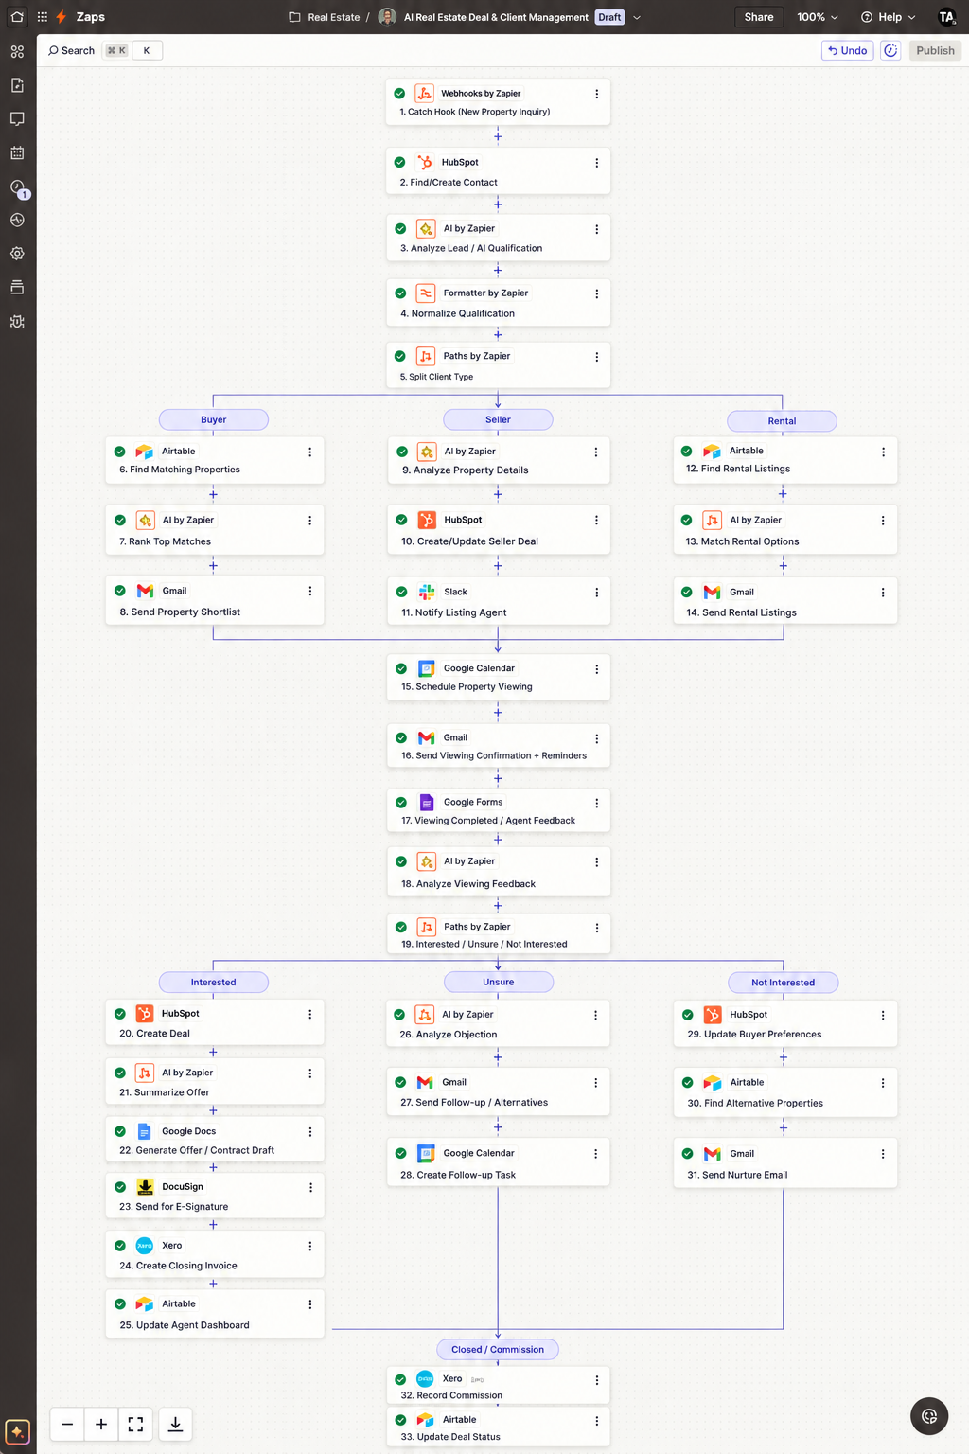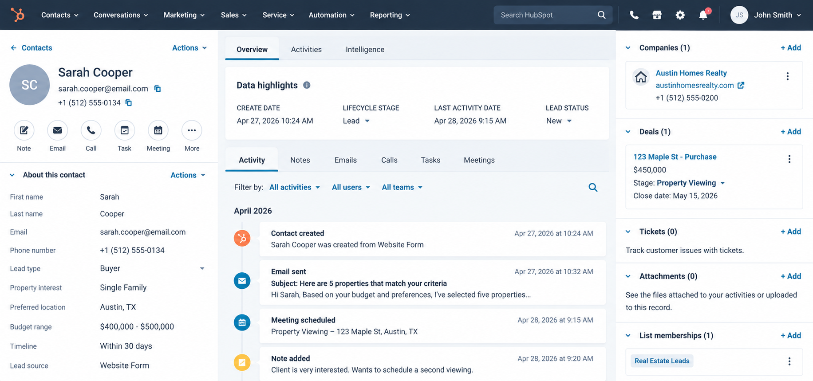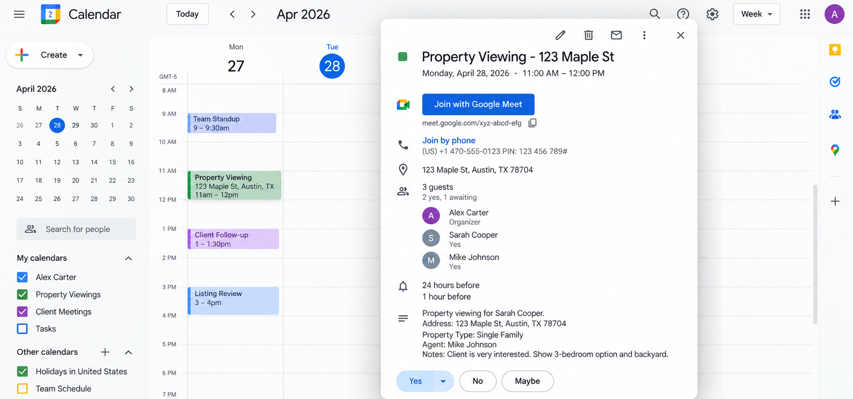

Buyer & Rental Matching
For buyers and renters, the system matches available properties using:
• Budget
• Location
• Property type
• Bedrooms
• Amenities
• Timeline
Matching properties are stored and retrieved from Airtable before being sent to the client.

Seller Workflow
Seller information includes:
• Property address
• Property type
• Bedrooms
• Bathrooms
• Estimated value
• Selling timeline
The system creates or updates the seller opportunity in HubSpot and notifies the assigned agent.

Property Communication
Personalized property emails include:
• Matching properties
• Property details
• Client requirements
• Pricing information
• Viewing options

Viewing Automation
When a client wants to view a property:
• Creates a Google Calendar event
• Sends booking confirmation
• Sends a 24 hour reminder
• Sends a 1 hour reminder

Post Viewing Workflow
After the viewing, the agent records:
• Client interest
• Offer potential
• Main objections
• Price concerns
• Property fit
• Next action
The information is then routed into the appropriate follow up process.

Offer & Closing
For interested clients:
Viewing → Offer → Deal → Contract → E Signature → Closing
The system updates the CRM and notifies the agent throughout the process.

Commission Management
After closing:
• Calculates the commission
• Creates the required invoice
• Updates commission information
• Records the completed transaction

Technology
• Zapier
• Webhooks
• HubSpot
• OpenAI
• Airtable
• Gmail
• Google Calendar
• Xero
• E Signature

Result
A complete real estate automation system that connects property inquiries, client qualification, property matching, viewings, follow ups, offers, contracts, closing, and commission tracking into one streamlined workflow.

